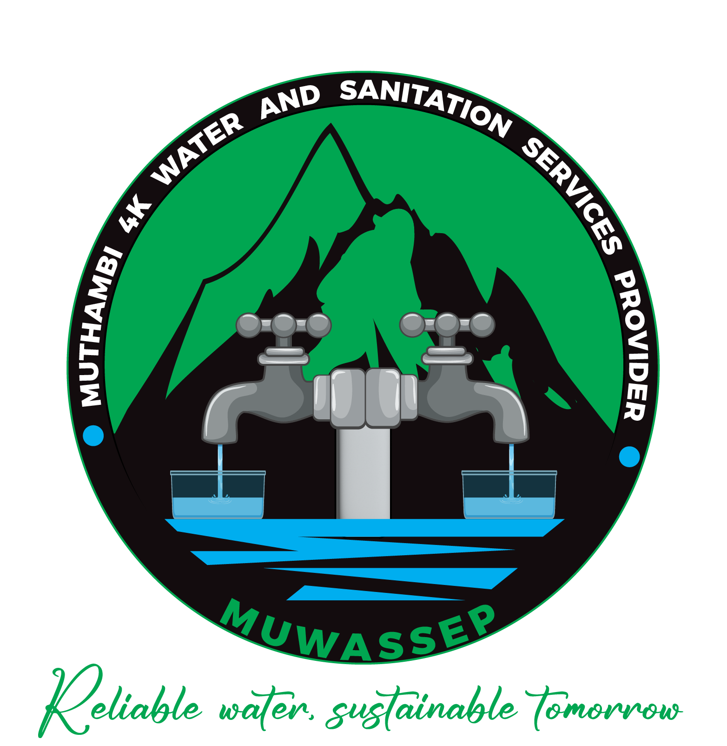 STRATEGIC PLAN
2024/2025-2028/2029

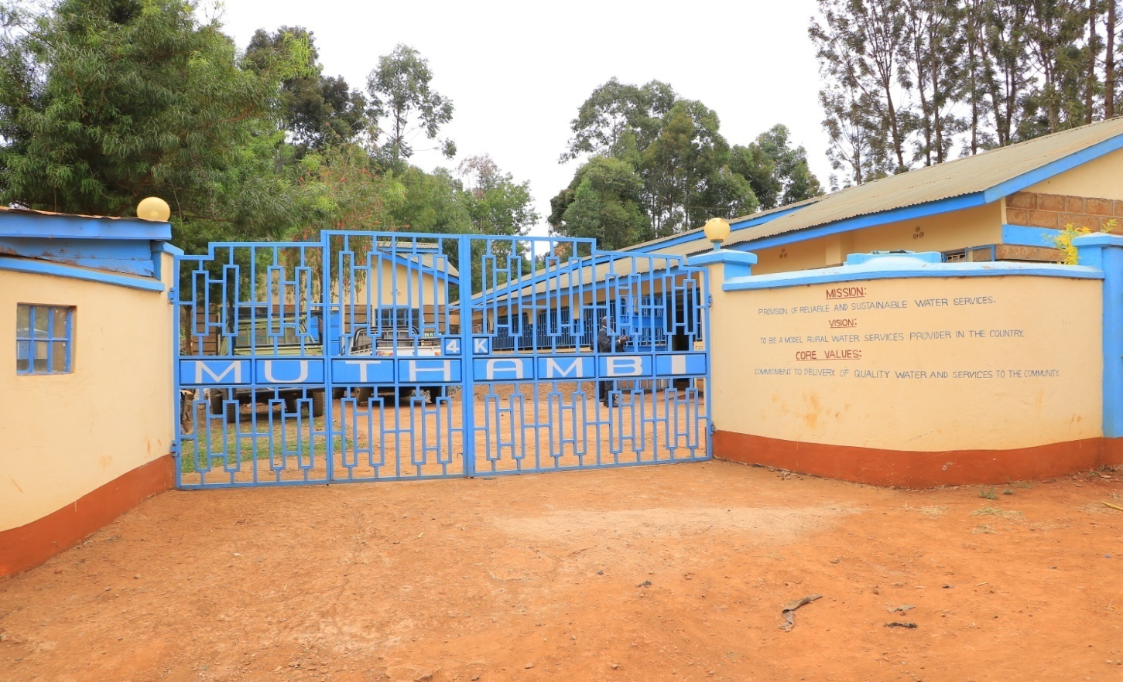

MUTHAMBI 4K WATER AND SANITATION PROVIDER
ADMINISTRATIVE OFFICE BLOCK
P.O. BOX 343-60401
CHOGORIA
MUTHAMBI SUB- COUNTY
THARAKA NITHI COUNTY
REPUBLIC OF KENYA
Mobile Number: 0718547721, 0728281190
E-mail: muthambiwater@gmail.com

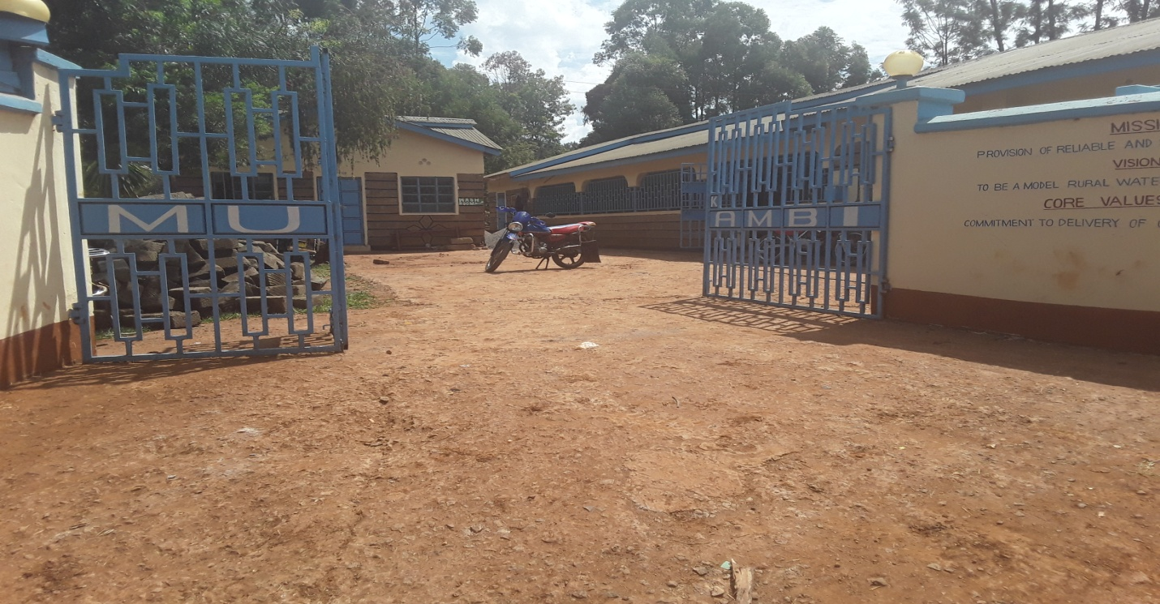

MUTHAMBI 4K WATER AND SANITATION PROVIDER
ADMINISTRATIVE OFFICE BLOCK
P.O. BOX 343-60401
CHOGORIA
MUTHAMBI SUB- COUNTY
THARAKA NITHI COUNTY
REPUBLIC OF KENYA
Mobile Number: 0718547721, 0728281190
E-mail: muthambiwater@gmail.com

BOARD OF DIRECTORS – MUWASSEP
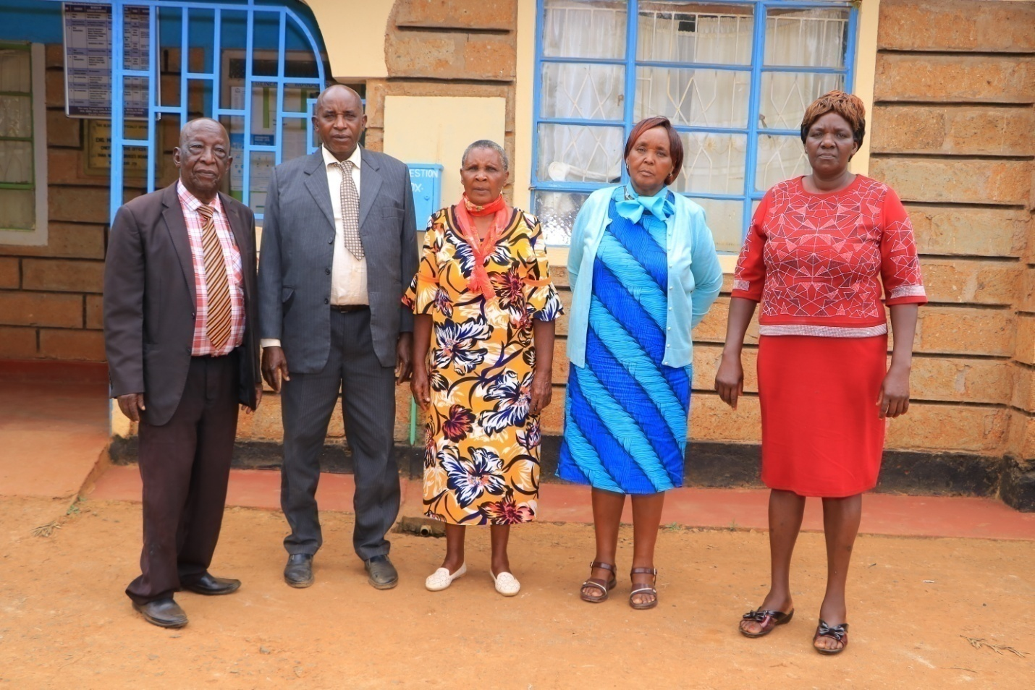

From Left
- MR. GERMANO MUNDI - CHAIRMAN
- MR. PHIMINOUS KABURU - DEPUTY CHAIRMAN
- MRS. EVELYN K. NJERU - FINANCE COMMITTEE CHAIR
- MRS. SANTINA I. MARANGU - BOARD MEMBER
- MRS. MARY M. GITONGA - BOARD MEMBER

COMMUNITY ZONAL REPRESENTATIVES OF THE BOARD
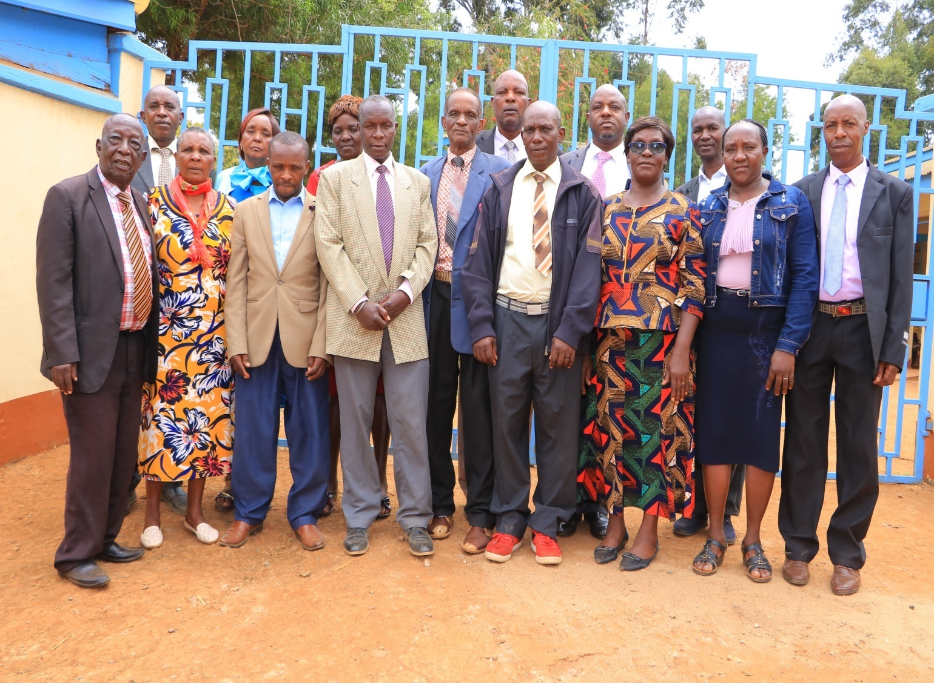

WSP Governance structure
The policy making of the WSP is entrusted to the Board of Directors which is composed of 5 Directors. During the AGM the members elect 15 representatives of the zones within the service area. The 15 representatives elect the 5 directors based on zonal representation and competence

STAFF MEMBERS OF MUTHAMBI 4K WSP- 2018
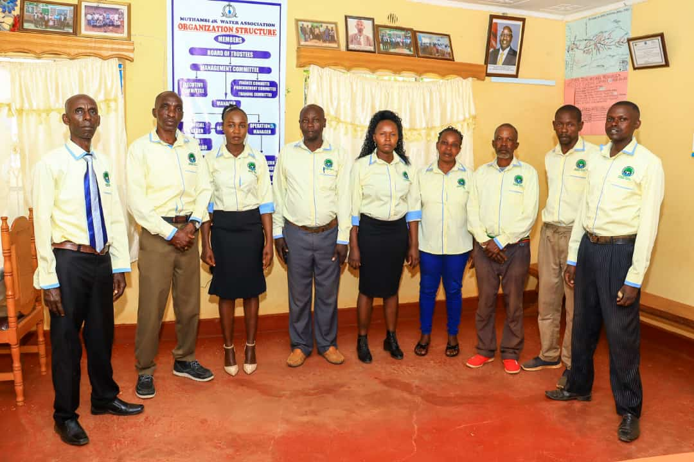

From Left

- ELIPHELET NJIRU - GENERAL MANAGER
- PETER GITONGA - TECHNICAL MANAGER
- CELINA GATUGI - ACCOUNTANT
- ELIAS MBAE - SENIOR PLUMBER
- TABITHA MUTHONI - I.C.T
- DAMARIS GATAKAA - CASHIER
- NYAGA BENSON - PLUMBER
- EDRICK MUTWIRI - PLUMBER
- ERICK MUCERI - PLUMBER

TABLE OF CONTENTS

BOARD OF DIRECTORS – MUWASSEP iv
COMMUNITY ZONAL REPRESENTATIVES OF THE BOARD v
STAFF MEMBERS OF MUTHAMBI 4K WSP- 2018 vi
TABLE OF CONTENTS vii
LIST OF TABLES x
LIST OF FIGURES xi
LIST OF ABREVIATIONS AND ACRONYMS xii
FOREWORD xiv
LICENCE AREA OF THE WSP AS PER WASREB GUIDELINE xvii
ACTUAL SERVED AND UNSERVED AREAS AS AT 2018 xviii
CHAPTER ONE 1
INTRODUCTION AND BACKGROUND 1
1.1 Introduction 1
1.2 Fundamental statements of Muthambi 4k water and sanitation service provider (MUWASSEP) 1
1.2.1 Vision statement 1
1.2.2 Mission statement 2
1.2.3 Mandate statement 2
1.2.4 Core functions 2
1.2.5 Core values 2
1.2.6 Philosophy 3
1.3.1 Graphical representation of resource mobilization 4
1.4 WSP GOVERNANCE STRUCTURE 4
1.4.0 GOVERNANCE 4
1.4.1 BOARD OF DIRECTORS 4
1.4.2 Management team 5
1.5 Achievements, gains and lessons learnt while operating without a formal strategic plan. 5
1.5.1 Achievements and Gains 5
1.5.2 Lessons Learnt While Operating Without a Strategic Plan 6
1.5.3 Challenges while operating without a strategic plan. 6
1.6 Human resources in terms of skills, competences and numbers 8
1.6.1 Organization Structure 8
CHAPTER TWO 11
FORMATIVE ANALYSIS 11
2.1 Political, Economic, Social, Technological, Environmental and Legal analysis 11
2.1.1 The Political 11
2.1.2 Economic 11
2.1.3 Social- Cultural Environment 12
2.1.4 Technological Environment 12
2.1.5 Environmental 13
2.1.6 Legal 14
2.2 Situation analysis 14
2.2.1 Infrastructure, their physical status and distribution network 14
2.2.2 Water demand as at 2023 17
2.2.3 Status of the current operations 17
2.2.3.1 Water service levels 17
2.2.4 Financial performance of WSP 18
2.2.5 Operation costs 18
2.2.6 WSP Stakeholder’s analysis 20
2.2.7 S.W.O.T Analysis 27
CHAPTER THREE 28
STRATEGIC OBJECTIVES AND DIRECTION 28
3.0 Introduction 28
3.1 Strategic issues 28
3.2 Strategic Goals 28
3.3 Strategic Objectives 29
3.4 Strategic plan output, outcome and impact 33
CHAPTER FOUR 35
IMPLEMENTATION OF THE STRATEGIC PLAN 35
4.0. Introduction 35
4.1. Implementation 35
4.1.1 Approach 35
4.1.2 Process 36
4.1.3 Capacity building /development of skills to implement SP 36
4.3 Strategic financial projection plan 61
4.4 Source of funds for the plan period 62

LIST OF TABLES
Table 1: Funding trend to date 3
Table 2: Achievements as per the key result areas as published by WASREB 7
Table 3. Distribution network 16
Table 4. Water Demand Analysis 17
Table 5: General Service levels (2021/2022) 17
Table 6: Revenue and revenue collection efficiency 18
Table 7: WSPs operation cost trend versus surplus/deficits 19
Table 8. WSPs cost coverage if collection efficiency was 100% 19
Table 9. Project financial statistics for plan period 20

Table 10: Stakeholder’s analysis………………………………………………...……… ……. 21
Table 11. S.W.O.T Analysis 27

LIST OF FIGURES

Figure 1. Graphical representation of resource mobilization 4
Figure 2: Representations of Achievements as per the Key Result Area 7
Figure 3. Revenue collection trend in millions 8
Figure 4: Current organization structure details 9
Figure 5. Revised organizational structure for strategic plan 10

LIST OF ABREVIATIONS AND ACRONYMS
BOD : Board of Directors
CBA : Collective Bargaining Agreement
CDF : Constituency Development Fund
CRO : Customer Relations Officer
COK : Constitution of Kenya
HIV/AIDS : Human Immune Virus/Acquired Immune deficiency Syndrome
TM : Technical Manager
CM : Commercial Manager
HRO : Human Resources Officer
ICT : Information Communication Technology
GM : General Manager
IT : Information Technology
KEBS : Kenya Bureau of Standards
MDG : Millennium Development Goals
MIS : Management Information System
MOU : Memorandum of Understanding
NEMA : National Environment Management Authority
NGO : Non Governmental Organization
NRW : Non- Revenue Water
MUWASSEP : Muthambi 4K Water and Sanitation Services Provider
PMS : Performance Management System
PO : Procurement Officer
PPP : Public Private Partnership
SPL : Service Provision License
SWOC : Strengths, Weaknesses, Opportunities and Challenges
WWDA : Water Works Development Agency
TNCIDP : Tharaka Nithi County Integrated Development Plan
WASREB : Water Services Regulatory Board
CGTN : County Government of Tharaka Nithi
WSS : Water Supply and Sanitation
WSPs : Water Services Providers
EMCA : Environmental Management and Co-ordination Act, 1999
PRO/RMO : Public Relations Officer/Resource Mobilization Officer
PA : Personal Assistant to the GM
IAO : Internal Audit Officer
DCO : Debt Control Officer
MRO : Meter Reading Officer
BC : Billing Clerk
MRS : Meter Reading Supervisor
D+R Team : Disconnection and Reconnection Team
PO : Procurement Officer
SC : Stores Clerk
HRA : Human Resource Assistant
TO : Transport Officer
IAA : Internal Audit Assistant
WPS : Water Production Supervisor
ADO : Asset Development Officer
WQO : Water Quality Officer
4K : Kariethera, Kaathi, Kabuuri, Kandungu
NRWO : Non Revenue Water Officer
LT : Lab Technologist

FOREWORD
Muthambi 4K Water Services Provider is gland to present its first Strategic plan which has been prepared with the aspirations of the Country’s Development Agenda as expounded in Vision 2030, and other policy documents of the National and County Governments, notably the Water Act 2016, in mind.
Since the establishment of Muthambi 4K as a Community Based Water Service Provider, significant achievements have been made in the key areas of water infrastructure, production capacity, and efficiency in service delivery to our customers. This has propelled the WSP to the position of serving the customers optimally in terms of management and effective service delivery while moving towards being a role model in community Water Service provision.
To maintain and exceed Muthambi 4K growth and in particular provision of quality water to the community and the institutions within our supply area, the WSP is faced with many challenges which are anticipated to be addressed by this strategic plan. In order to deal with these challenges, the BOD and the management are also committed to carry out continuous reviews on all areas of operations to ensure that the WSP is well prepared to cope with the challenges of a dynamic business environment as and when such challenges and opportunities arise.
Muthambi 4K 1stStrategic Plan will provide the plan that sets clear goals and objectives that describes a number of strategies and action plans that will further lead us towards the attainment of our vision, mission and mandate of being a vibrant Water and Sanitation Service Provider in Tharaka Nithi County. Our key areas of focus during the next five years have been identified and prioritized through the five strategic objectives and their corresponding strategies and supporting action plans. These will dictate the areas to which the WSPs efforts and resources will be directed.
The Strategic plan was prepared through a policy direction issued by the Board of Directors and a collective process involving the top management and the Section Heads of the various sections /Units of the WSP as well as a valuable input and contribution from the full Board members.
Lastly, I wish to thank all the Board members who provided guidance during the process of developing this strategic plan and the members of staff who actively participated in all the required discussions presented by the facilitator. My appreciation also goes to the WSP Facilitator who assisted greatly to make the document a reality.
Our staff have no doubt benefited from the technical know-how in forward planning and strategic planning and reviews.

Regards to all

Germano Mundi
Chairman

EXECUTIVE SUMMARY
I am delighted to present the first strategic plan of Muthambi 4K water Services Provider. This plan has been synchronized with the Governments’ Financial Year and will consequently run from 2024/2025 to 2028/2029
In our continued pursuit of excellence and vision of becoming the model water services provider, we have formulated strategies that will enable us to respond appropriately to the needs, challenges and opportunities of a rapidly changing operating environment, while still focusing on our primary objective which is provision of clean/safe water and sanitation services to residents of Muthambi ward and Mbetini village within Igamba Ngombe ward This document has reviewed and highlighted the strategic objectives that will mainly contribute to the envisioned measurable results. The primary strategic objectives prioritized in this plan include;
- To increase access and coverage to water services in our area of jurisdiction from 65% to 75% by the year 2028
- To reduce non-revenue water from 59% to 49% within the plan period
- To achieve operational financial sustainability from 90% to 120%.by end of the plan period
- To strengthen the WSPs institutional capacity by 50%within the plan period
The strategic plan also articulates the vision, mission and the core values of the WSP for purpose of having a focused future plan and way of doing business. Detailed implementation and monitoring framework have been provided in which the objectives, strategies, activities, performance indicators, outputs and outcomes are spread over the five years and clearly stipulated. In order to actualize our vision, our focus during the next five years will entail among others,
- Enhanced financial sustainability,
- Enhanced efficiency in infrastructure usage and operations,
- Increased automation of our operations and services,
- Maintaining and attracting a competent skilled and adequate human capital,
- Uplifting of the WSP Corporate image and publicity.
We finally acknowledge with thanks the valuable input and comments from the Board of Directors, all staff members and our stakeholders in the development of this strategic plan.

Eliphelet Njiru
General Manager

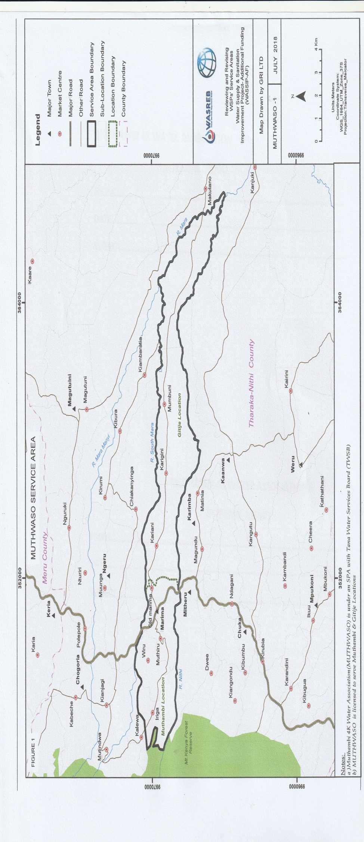
LICENCE AREA OF THE WSP AS PER WASREB GUIDELINE

Wasreb map indicating allocated area of water supply

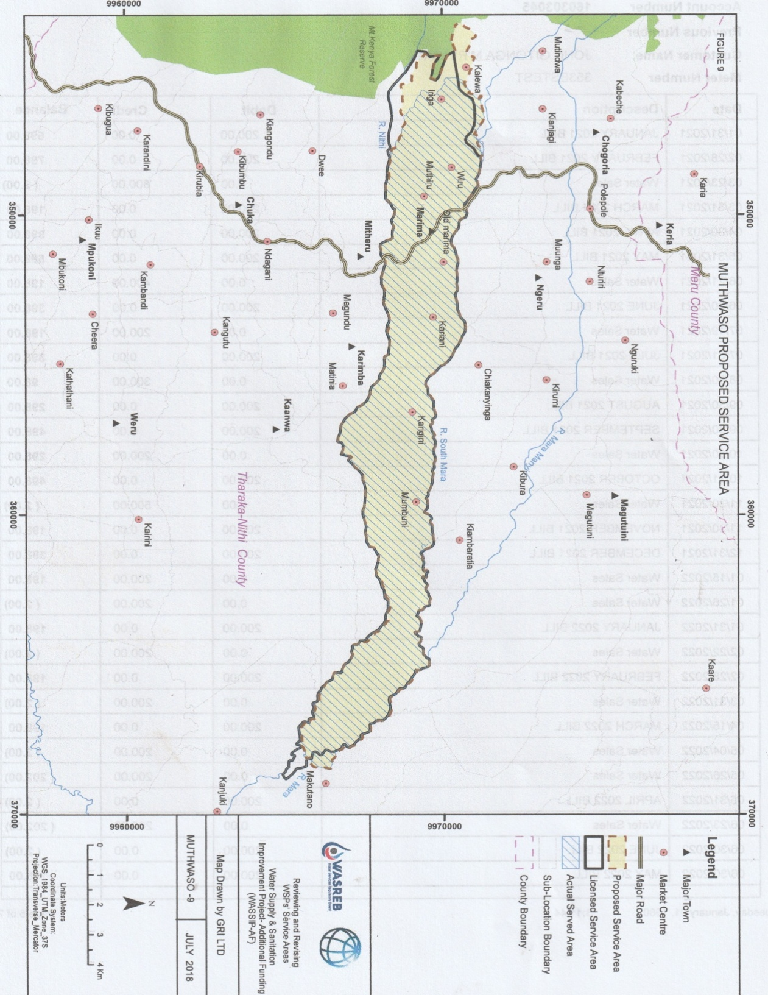
ACTUAL SERVED AND UNSERVED AREAS AS AT 2018

CHAPTER ONE

INTRODUCTION AND BACKGROUND

FOUNDAMENTAL REVIEW FRAMEWORK

1.1 Introduction
Muthambi 4K Water and Sanitation Services Provider (MUWASSEP) was founded in 1982 after the almagation of 4 small water projects whose names started with letter K. The said small water projects were Kariethera, Kaathi, Kabuuri and Kandungu. The four small water projects pooled their resources together and initiated the WSP by registering as Muthambi 4K Water Project with the ministries of Social services and Water development.
The Water project commenced on constructing the first intake works at Mwithanga stream which is a tributary of South Mara River. In the year 1998, the water project opted to register the group under the Societies Act so as to attain a better legal status and thereafter the official name of Muthambi 4K Water Association was attained. Later in the year 2004, the National Government through the former Tana Water Services Board impressed on the society to follow the Government regulations as per the Water Act 2002.
Muthambi 4K Water Association was recognized and approved to be a WSP by Tana Water Services Board currently TWWDA and issued with a Water Service Provision Agreement (SPA) in 2004. The Water Association operated under the SPA until the Water Act 2016 was operationalized.
In 2023, WASREB, TWWDA and TNCG sensitized the WSP to obtain the water services license under the Water Act 2016 which is mandatory to all Water and Sanitation Service Providers. Therefore, development of this 1st Strategic Plan for Muthambi 4K Water and Sanitation Services Provider (MUWASSEP) is to meet one of the License application Conditions.

1.2 Fundamental statements of Muthambi 4k water and sanitation services provider (MUWASSEP)

1.2.1 Vision statement
To be a model community rural water services provider in the country (Kenya)

1.2.2 Mission statement
Provision of reliable adequate and sustainable water services

1.2.3 Mandate statement
Muthambi 4K Water and Sanitation Services Provider (MUWASSEP) is responsible for the efficient and economical provision of water and sanitation services within its area of jurisdiction.

1.2.4 Core functions
- Provide water and sanitation services within Muthambi ward as specified in the license.
- Exercise overall control over the supply of water and sanitation services in the specified area as issued by WASREB
- To abstract water for the purposes of distribution and supply from all our appropriate sources namely Mwithanga, South Maara and Nithi rivers.
- To undertake water quality analysis to ensure that acceptable water quality standards are maintained.
- To levy water consumer charges as approved by the stakeholders/WASREB in respect of the services which the WSP provides.

1.2.5 Core values
- Quality service and Customer focus
- Transparency and Accountability
- Good governance
- Innovation
- Teamwork
- Integrity

1.2.6 Philosophy
Reliable water sustainable tomorrow

1.3 Muthambi 4k water and sanitation services provider (MUWASSEP)

Table 1: Funding trend to date
 | PROJECT | FINANCIAL YEAR | AMOUNT (KSH)
1 | Tana Water Works Development (Pipe & fittings) | 2007 - 2023 | 21,649,145
2 | (WSTF) Mainline improvement and sanitation project | 2019-2020 | 4,827,330
3 | CDTF ( Booster line, T/W | 2005-2006 | 11,967,302
4 | Tharaka Nithi County Government (pipes) | 2013-2014 | 1,581,250
5 | National Government ( pipes) | 2009-2010 | 9,923,530
6 | CDM (Consumer Meters) | 1996 | 731,062
7 | SIDA ( Tank, Pipes Capacity Building) | 1994-1996 | 15,963,784
8 | MISSERIOR (Office construction and training) Sanitation | 2010-2011 | 4,397,563
9 | UTaNRMP ( PIPES AND METERS) | 2018-2019 | 6,367,749
10 | Community Contribution ( material and labour as required) | Since inception | 26,218,299
 | Total |  | 103,627,014

The WSP has implemented projects worth KSh 103,627,014 funded through various
Organizations/partners as detailed above to date.

1.3.1 Graphical representation of resource mobilization

Figure 1. Graphical representation of resource mobilization

1.4 WSP GOVERNANCE STRUCTURE

1.4.0 GOVERNANCE

1.4.1 BOARD OF DIRECTORS
The policy maker of the WSP is entrusted to the Board of Directors which is composed of 5 Directors. During the AGM the members erect 15 representatives of the zones within the service area. The 15 representatives elect the 5 directors based on zonal representation and competence.
The 15 representatives of the zones are elected based on the representation of the interest groups as tabulated below-
- Business community
- Women groups
- County government
- Educational institutions
- Coffee Societies
- Professional bodies
- Religious group

The board is headed by a Chairman who is elected by other directors. The board operates through 3 sub committees namely
- Finance and administration committee,
- Technical Committee (Procurement and stores)
- Audit Committee (Training and Educational)

The role of the board is primarily that of providing strategic direction and leadership (policy) to the WSP.

1.4.2 Management team
This comprises of the General Manager, Commercial Manager and Technical Manager as the top management team (CMT). CMT is responsible for the day to day running of the WSP. The CMT also play the secretarial duties of the relevant committees of the Board. Internal Auditor is the secretary to the Audit Committee of the board. Human Resources Officer provide backup to the top management for the day to day running of the WSP.

1.5 Achievements, gains and lessons learnt while operating without a formal strategic plan.

1.5.1 Achievements and Gains
- Completed the Administration Block
- Partly developed water sources in Mt Kenya Forest which does not meet our water demand
- Currently managing a total of 3200 Registered Connections as at October 2023.
- ICT Technology is at 60% level in various departments within the WSP.
- Staff skills development for better management is on-going
- Registered the WSP under the various Government Ministries and parastatals.

1.5.2 Lessons Learnt While Operating Without a Strategic Plan
- Stakeholders’ low confidence on WSPs future Strategic direction since it’s not documented.
- Lack of a documented road map of where we want to be, how we shall get there and when we want to be there.
- Lack of strategic financial projections which would otherwise enhance revenue collections to ensure long term financial sustainability.
- Skilled manpower and professional approach on the management of the WSP is a necessity.
- Development partners’ engagement and confidence is critical for attainment of increased investments.

1.5.3 Challenges while operating without a strategic plan.
- Inadequate funding to achieve our mandate
- Inadequate preparedness when disasters happen.
- High Non-Revenue Water levels
- Old and Dilapidated infrastructure which occasions high O+M costs and high NRW levels
- Unregulated Community water projects operating in our area of supply who provide low tariff services which also affects our tariff setting strategy.
- Ever growing high water demand due to rapid peri-urbanization within our service area.
- Inadequate transport facilities to cover the vast service area.

Table 2: Achievements as per the key result areas as published by WASREB
NO | INDICATOR | FY 2017/2018 | FY 2018/2019 | FY 2019/2020 | FY  2020/2021 | FY  2021/2022
1 | Water Coverage % | 91 | 54 | 56 | 51 | 58
2 | Sanitation Coverage % | 78 | 81 | 92 | 94 | 100
3 | Metering Ratio % | 100 | 100 | 100 | 100 | 100
4 | NRW % | 36 | 21 | 28 | 25 | 20
5A | Revenue Collection  ( Kshs Million) | 3,967,613 | 6,845,032 | 6,120,286 | 6,621,750 | 7,116,881
5B | Revenue Billed (million) | audited  4,815,567 | audited  8,052,979 | audited  7,822,625 | audited  8,277,195 | audited  8,275,444
6 | Collection Efficiency % | 82 | 85 | 78 | 80 | 86

Source of data Published WASREB impact report

Figure 2: Representations of Achievements as per the Key Result Area

Figure 3. Revenue collection trend in millions

1.6 Human resources in terms of skills, competences and numbers
The WSP recognizes the regulator’s guidelines of maintaining an establishment of 9 members of staff per every 1000 connections. The WSP also works towards being a model WSP and a learning organization for the other community Water projects within the county. To facilitate the implementation of the strategic plan, the WSP is equipping and engaging in capacity building of the staff members’ interms of their skills capacities and competences. As need arises, the WSP outsources the necessary expertise.
Staff trainings will be conducted where knowledge and skill gap are identified through training needs assessment process. It is noteworthy that as part of staff development the WSP is anticipating to take the employees through refresher courses to ensure that the right attitude in the workplace is upheld at all times.

1.6.1 Organization Structure
The attached organizational structure below, represents the current situation which is has been reviewed for adoption in the new strategic plan. It is believed that the reviewed structure is capable of delivering the strategic plan/goals without major alterations.
The reviewed organization structure shall be implemented within the five year strategic plan as vacancies arises which are demand driven once such vacancies are approved by the Board of Directors. The organization structure demonstrates maximum establishment within the period of the strategic plan.

Figure 4: Current organization structure details

CURRENT ORGANIZATION STRUCTURE DETAILS
TECHNICAL MANAGER 1
ACCOUNTANT 1
FIELD SUPERVISOR 1
I.C.T / BILLING CLERK 1
GENARAL MANAGER
AGM
BOARD OF TRUSTEE
BOARD OF DIRECTORS

BOARD OF MANAGEMENT

CASHIER 1
PLUMBER 3

NOTES: The following services are normally outsourced - Meter readers (one week in a month), Human Resource is under Accountant office, line patrollers and watchmen under direct community members contribution,

Figure 5. Revised organizational structure for strategic plan
CLEANING SERVICES
SECURITY SERVICES
TRANSPORT OFFICER
ARTISANS(2)
PLUMBERS/ METER READERS(16)

BILLING CLERK(1)
REVENUE CLERK(1)
ACCOUNT CLERK(1)
OPRATIONAL SUPERVISOR
N.R.W(1)
WATER QUALITY(1)
FIELD SUPERVISOR(2)
HR(1)
PROCUREMENT OFFICER(1)
I.C.T(1)
ACCOUNTS OFFICER(1)
Technical manager
Commercial manager
INTERNAL AUDIT
GM
AGM/ Trustees
BOARD OF MANAGEMENT

Revised organizational structure For Strategic plan.
NB. The revised plan shall be implemented once the WSP is 130% Cost coverage. Therefore the current organogram shall remain in place till then.

Plan
Total Staff

CHAPTER TWO

FORMATIVE ANALYSIS

2.1 Political, Economic, Social, Technological, Environmental and Legal analysis (PESTEL)
The PESTEL analysis was undertaken through a scanning of the WSP macro environment to ascertain the current challenges and opportunities that are likely to impact on the operations of the WSP during the plan period. This analysis revealed the following:

2.1.1 The Political
The following were identified as some of the political factors that are likely to impact on us:
- The 2022 general elections- new leaders will come with new perspectives.
- Employment laws- people becoming more aware of their rights
- Business interference and competition- WSP experiencing threats and interference from unregulated water service providers within our defined water service provision area.
- Bill of rights – threats of people demanding water services through litigation/political incitement and demand for free water services.
- Water funds available for WSP’S but it’s a condition fund.

2.1.2 Economic
- The current tariff structure has been in force since 2015 while the inflation rate has been raising yet no tariff changes, ability to pay has not been an issue but WSP ownership by the customers has been a limiting factor.
- Water production cost has been on increase and are expected to affect the WSP due to increased demand of water services.
- Multiple levies by various offices- NEMA, WASREB, KFS, WARMA, etc is likely to put pressure on the WSP revenues.
- Inability by WSP to meet the funding requirement as placed by the WSTF and development partners.
- Dilapidated and aged infrastructure leading to high operational costs and high non- revenue water levels.
- Susceptibility of soils and terrain to landslides which occasion disasters to human life and infrastructure leading to high operational costs and compensation claims.

2.1.3 Social- Cultural Environment
- The changing lifestyle due to urbanization is likely to trigger demand for 24hours water supply hence better revenues.
- Malicious persons in the society could use propaganda e.g. water is for free or unfit for consumption and this could affect the demand negatively.
- Ignorance and misinformation by some people has led to operational problems.
- Cases of epidemic like CORONA and other communicable diseases cropping up at high rate thus affecting customer’s ability to pay for water services.
- Youth dependency syndrome- youth depending on old who are not in a position to pay for the water.
- Belief that water is God given and should be free contributes to consumers sluggishness in payment of the bills and therefore temptation to engage in water theft which calls for sensitization.
- Provision of clean piped water has led to increased cleanliness and health, thus a better standard of living in the community.
- Need for staff and customers for corporate culture change in matters such as water theft, corruption and debt management.

2.1.4 Technological Environment
Use of ICT is widely recognized worldwide as a major vehicle to accelerate effective and efficient service delivery. Some of the factors likely to have an impact on WSP operations include:-
- Automation of the operational systems e.g. Mobile meter reading and associated equipment to improve billing system shall lead to improved operational efficiency and sustainability in service delivery.
- Need for adequate skills and capacity.
- Debt management challenges on the WSP.
- Use of the internet and availability of website.
- High rate of technological changes could become very expensive owing to frequent change of equipment, software and retraining of staff thus affecting their very purpose of increasing efficiency and attaining cost effectiveness.
- Monopoly of knowledge where one person can do a lot of work alone. There is a danger in such a situation in that an individual can hold the company at ransom.
- Cloud computing. No need to invest in more servers.
- Increase in threat of data loss through vices such as theft, damage, hacking and possible sabotage.
- Security of ICT is critical issue in any business that embraces computerization as mishandling could easily cripple the operations of an entire organization.
- Cost of research and development. In a situation where many needs are competing for scarce resources research and development are given a lesser weight in terms of priority.
- Possibility of staff resisting new technology. New technology interferes with the way of doing things’ and a lot of the staff receive it with a degree of apprehension.

2.1.5 Environmental
- The formation of Water Resources Users Association (WRUA) for protection of water bodies has positively enhanced the protection of water sources within our area of jurisdiction.
- The enactment of EMCA enabled establishment of NEMA which helps WSP to attain the required regulatory permits and licenses to implement new projects.
- The global warming is affecting our water sources and has a future impact on the implementation of this strategic plan Encroachment of our Water Towers (Mt Kenya Forest) has also a negative effect on the water sources feeding WSP.
- Human activities like cultivation of catchment areas resulting to high silt load in the water requires a lot of treatment before it can be use for drinking

2.1.6 Legal
- Government regulations e.g. on tariff control, performance indicators likely to affect our profitability.
- The Water Act 2016 changes in relation to water service provision especially at regulatory level. Changes at this level will invariably have ripple effect in the water industry especially at WSP level.
- Water has become a human rights issue. As the commodity gets more and more scarce the perspective is changing with consumers and rights groups agitating for equality in its usage.
- Employment through regionalism. Devolution and county government system envisaged in the constitution is bound to bring out regional and, if not carefully handled, ethnicity among the populace. We are already seeing communities agitating for more employment opportunities within the WSPs that operate within their localities.
- The 2010 Constitutional challenges e.g. Bill of rights, Gender mainstreaming etc.
- Challenges in acquiring road crossing approvals from relevant authorities e.g. KeNHA and KERRA causing delay in completion of projects.

2.2 Situation analysis

2.2.1 Infrastructure, their physical status and distribution network

Muthambi 4K Water and Sanitation Service Provider (MUWASSEP) is entirely gravity operated water supply system. The major infrastructure facilities and components are:-

a. Intake Works
The WSP operates 3 water intakes namely MWITHANGA Water Intake, Maara intake Works, and Nithi Intake Works. The three intakes are cross weir facilities at Mt Kenya Forest.
The intake Works comprises of one master meter and three intake chambers. All of them are 100% operational.
Challenges at the Intake Works
- Siltation
- Low pre treatment due to lack of efficient screens
- Landslides and logging during rainy season is a challenge
- Insecurity and vandalism
- Low water flows due to human activities in the forest
- Water quality pollution due to wildlife interferences

b. Treatment Works
Mwithanga and Nithi intake works share one treatment works located at Kalewa shopping centre. Mara intake works has its own treatment works at Muthambi Primary School grounds.
Currently only sedimentation tanks are operational at the various treatment works. Chlorination equipments have not been operating due to technical challenges beyond the ability of the WSP.
- Theft of equipments
- Qualified staff to run the T/works

c. Raw Water Mains
All the Raw Water mains run untapped from the Intake works to the Sedimentation tanks where distribution of water takes place to all the customers.
Air valves on the mains are 50% operational. Washouts and sluice valves also not fully operational and the repairs and maintenance shall indicated required works.

Table 3. Distribution network
Storage reservoirs
Capacities and other relevant information
 | NAME OF STORAGE TANKS | Type | Location | Capacity  M³ | Status | Remarks
1 | Kirigi | Masonry | Iriga | 50 | Operational
2 | Karengi | Masonry | Iriga | 50 | Operational
3 | Kaigani | Masonry | Igamurathi | 10 | Operational
4 | Kajiunduthi | Masonry | Igamurathi | 60 | operational
5 | Itara | Masonry | Igamurathi | 25 | operational
6 | Kagongo | Masonry | Iriga | 10 | operational
7 | Rurea | Masonry | Chamunga | 25 | operational
8 | Rwanderi | Masonry | Chamunga | 25 | operational | To be relocated due to levels
9 | Ntatua | Masonry | Chamunga | 25 | operational
10 | Muthambi boys | Masonry | Chamunga | 60 | operational
11 | Ikindu | Masonry | Kandungu | 50 | operational
12 | Kanoro | Masonry | Kandungu | 25 | operational
13 | Kajiambaki | Masonry | Kandungu | 10 | operational | To be relocated due to levels
14 | Mumbuni | Masonry | Kandungu | 10 | operational | To reconstructed for 100 M3
 | Totals |  |  | 435

2.2.2 Water demand as at 2023

Table 4. Water Demand Analysis

 | Segregation | population | Water demand m³/day
1 | Households population | 19,890 | 1492
2 | Institutions | 4600 | 230
3 | Health Centres | - | 10
4 | Industries (coffee factories 3 no. Milk processing unit 2 no. | - | 30
5 | Provision for livestock and minor Irrigation | - | 2000
Total |  | 24,490 | 3762

NB 2019 census for Muthambi ward was 19,890. However all schools (Institutions) population is not included in the census hence computations has taken 50% of institutional population as an additional population resulting to 24, 490 people.

2.2.3 Status of the current operations

2.2.3.1 Water service levels

Table 5: General Service levels (2021/2022)
Indicator | Year(2021/2022)
Service provision area(km²) | 124
Population in service area | 19890
Total population covered | 12 952
Water Coverage | 65%
Total no. of active connection | 3224
Total no. of inactive connections | 14
Metered connections (%) | 3224
Total Registered connections | 3238
No. of employees | 9
Water demand (m3/d) | 3762
Water produced ( m³/d) | 4216
Water Billed ( m³/d) | 1719
Storage capacity (m³) | 435

2.2.4 Financial performance of WSP
Currently the financial stability of the WSP is marginal since the revenues generated marginally cover the operational costs of the WSP. This poses a great challenge when it comes to internal investments. Reference is made to the table below on revenue generated verses operating cost.

Table 6: Revenue and revenue collection efficiency
 | Year | Revenue | Revenue | Efficiency
 |  | Billed | Collected | (%)
 |  | (Kshs) | (Kshs)
1 | 2018/19 | 8052979 | 6845032 | 85
2 | 2019/20 | 7822625 | 6120286 | 78
3 | 2020/21 | 8277195 | 6621750 | 80
4 | 2021/22 | 8275444 | 7116881 | 86
5 | 2022/2023 | 8541202 | 7,174610 | 84

2.2.5 Operation costs
The table below shows the revenue collected and the operation costs during the last five years.
The figures indicate that for the 5 year period, the WSP had no surplus but operated on a deficit. Measures should be put in place to turn round the current business trend.

Table 7: WSPs operation cost trend versus surplus/deficits
 | Year | Revenue (Kshs)  Collected | Operation cost (Kshs) | Surplus/deficit (Kshs) | billing
1 | 2018/19 | 6845032 | 5,916,952 | 928080 | 8052979
2 | 2019/20 | 6120286 | 5,539,484 | 580802 | 7822625
3 | 2020/2021 | 6621750 | 6724106 | -102,356 | 8277195
4 | 2021/2022 | 7116881 | 7564217 | - 447336 | 8275444
5 | 2022/2023 | 7174610 | 9154127 | -1,979517 | 8541202

Table 8. WSPs cost coverage if collection efficiency was 100%
 | Year | Revenue  Billed (Kshs) | Collection Efficiency | Operation and maintenance cost(Kshs | Surplus/deficit (Kshs) | Cost Coverage
1 | 2018/19 | 8052979 | 85 | 5,916,952 | 2,136,027 | 136%
2 | 2019/20 | 7822625 | 78 | 5,539,484 | 2,283,141 | 142%
3 | 2020/2021 | 8277195 | 80 | 6724106 | 1,573,089 | 123%
4 | 2021/2022 | 8275444 | 86 | 7564217 | 711,227 | 109%
5 | 2022/2023 | 8541202 | 84 | 9154127 | -612,925 | 93%

Table 9. Project financial statistics for plan period

Year | Revenue Billed | Collection Efficiency | Operational / Maintenance Cost | Surplus | Cost coverage
23/24 | 8,622,573 | 89% | 9,580,637 | -957,764 | 90%
24/25 | 8,703,944 | 94% | 9,259,514 | -555,570 | 94%
25/26 | 8,785,315 | 99% | 8,878,056 | -88,741 | 99%
26/27 | 8,866,686 | 95% | 8,444,463 | 422,223 | 105%
27/28 | 8,948,057 | 89% | 7,989,337 | 958,720 | 112%
28/29 | 9,029,428 | 83% | 7,524,523 | 1,504,905 | 120%

2.2.6 WSP Stakeholder’s analysis
A stakeholder is any person, group or organization that has a claim/stake in the WSP. The relevant and major stakeholders for the WSP, their functions and interests are summarized in the Table below
These stakeholders are consulted on major issues touching on the WSP and also issues touching on customers. We relate with them through AGM forums.

Table 10: STAKEHOLDER’S ANALYSIS

 | STAKEHOLDER | ROLE | INTEREST | POTENTIAL STRATEGIES FOR ENGAGEMENT
1 | County Government of Tharaka Nithi | Develop infrastructure  Come up with water legislation  Provide Oversight  Capacity Building | Improved service delivery  Proper maintenance and operation of infrastructure  Compliance with legislations | Regular meetings  Inclusion in the Board of Directors  Write proposals  Submit monthly reports
2 | Education Institutions | Consume water services  Pay for water services  Safeguard water infrastructure within their premises | Reliable and sufficient supply of safe drinking water  Provision of sanitation services  Timely communication on supply matters | Regular engagement  Representation in the Board of Directors  Ensuring sufficient and reliable supply
3 | Water Services Regulatory Board | Formulating regulations  Enforcement of regulations  Licensing  Approval of Tariff  Monitoring and evaluation | Compliance to set standards and regulations  Acceptable services to the customers  Timely application for licenses and tariff adjustments  Timely submission of performance reports  Payment of levies | Timely payment of regulatory levies  Timely response to raised issues  Timely submission of reports  Attending events
4 | Business Community | Consume water services  Pay for water services  Safeguard water infrastructure within their premises | Reliable and sufficient supply of safe drinking water  Provision of sanitation services  Timely communication on supply matters | Regular engagement  Representation in the Board of Directors  Ensuring sufficient and reliable supply of water services
5 | National Government Constituency Development Fund | Infrastructure development to institutions | Sufficient services to the institutions
6 | Special Groups (women, youth, people living with disability) | Consume water services  Pay for water services  Safeguard water infrastructure within their premises | Reliable and sufficient supply of safe drinking water  Provision of sanitation services  Timely communication on supply matters  To be given special consideration during tendering  Inclusivity in staffing | Internships and attachments  Reserve category during tendering  Affirmative action during recruitment and appointments
7 | Religious Institutions | Consume water services  Pay for water services  Provide an effective medium of communication  Moral guardians | Reliable and sufficient supply of safe drinking water  Provision of sanitation services  Timely communication on supply matters | Engage religious institutions to offer spiritual guidance  Utilize institutions to communicate to customers
8 | Water Sector Trust Fund | Funding service delivery improvement infrastructure  Funding of infrastructure development  Demarcation of pro-poor areas | Timely repayment of loans  Adherence to loan conditions  Proper books of accounts | Submit proposals  Having meetings  Providing feedback
9 | Water Resource Users Association | Safeguard water sources | Payment of subscription fees | Attending meetings  Retain membership
10 | Ministry of water and sanitation & Irrigation | Policy formulation  Major Infrastructure development | Adherence to policies  Improved service delivery
11 | Staff Union | Protection of staff interests  Improvement of industrial relations | Remittance of monthly deductions  Recognition  Improved staff interest | Meetings  Collective bargaining agreement  Proper communication and engagement
12 | Suppliers | Timely supply of goods and services | payment | Fair tendering process  feedback
13 | Kenya National Audit Office | Audit  Formulate template for presentation  Sending guidelines | Timely submission of finance statements  Proper statement of accounts  Submit to county | Timely submissions
14 | Development Partners | - | - | -
15 | Community water projects | Supplement our services | Monitoring water quality | Map all water community projects  Testing water quality
16 | Media | Public Relations  Communication to the public  Unbiased reporting | Payment of contracted services  Timely engagement  Accurate information | Invite media for events  Making of documentaries
17 | Health Institutions | Consume water services  Pay for water services  Safeguard water infrastructure within their premises  Source of sanitation data  Educate on health and sanitation issues  Enforce adherence health and safety requirements | Reliable and sufficient supply of safe drinking water  Provision of sanitation services  Timely communication on supply matters | Engage Health Institutions through the county Government  Share data  One on one engagement
18 | Professional Bodies | Training of staff  Provide professional advice  Provision of standards | Professionalism  Payment of subscription fees | Attending trainings  Inclusion in the board of directors  Ensuring payment of membership subscription  Ensuring professional staff are in good standing
19 | Financial Institutions | Provide banking services  Commercial financing for company  Provide credit facility to staff | Timely loan repayment  Timely remittance of staff loan deductions | Forward proposals for financing  Introduce check offs
20 | Farmers Organizations | Consume water services  Pay for water services  Safeguard water infrastructure within their premises | Reliable and sufficient supply of safe drinking water  Provision of sanitation services  Timely communication on supply matters | Regular engagement  Ensuring sufficient and reliable supply
21 | Non-Governmental Organizations | Assist in times of emergencies  Finance water supply to pro-poor  CSR activities | Proper feedback on the assistance offered | Seek partnerships in CSR activities
22 | Water Resource Authority | Conservation of water sources  Issuance of abstraction permits  Regulate abstraction from shared water sources | Timely payment of abstraction fees  Compliance with regulations | Timely renewal of abstraction permits  Submission of water production data  Engage in discussion on landslides
23 | National Environment Management Authority | Formulate regulations  Enforce regulations and standards  oversee environmental audits | Compliance to set standards i.e effluent quality  Carry out regular environmental audits | Submission of effluent quality results

2.2.7 S.W.O.T Analysis

Table 11. S.W.O.T Analysis

STRENGTHS | Good organizational structure  Competent staff  Adequate water production  Staff good working relationship  Gravitational water system  Increased automation  A going concern  Credit worthiness  High revenue collection efficiency
WEAKNESSES | Aging infrastructure  Inadequate office space  Inadequate transport  Low revenue generation  Inadequately motivated staff  High NRW level  High level of debtors  Inadequate working tools
OPPORTUNITIES | Wide coverage area  Adequate water at the sources  Favorable terrain for gravitational supply  Improved road network  Availability of financiers  Availability of technology  Improving Economic status of the society  Potential for introduction of sewer services  Continuously rehabilitated infrastructure
THREATS | Political interference  Pandemics  Poor terrain  Competition  Degradation of catchment areas  Unpredictable weather patterns  Vandalism of water infrastructure  Declining population numbers

CHAPTER THREE

STRATEGIC OBJECTIVES AND DIRECTION

3.0 Introduction
The strategic direction has been informed by lessons learnt, the realignment with the constitution and other emerging issues. (Quality of our services in reference to the changing environment)

3.1 Strategic issues
The following key strategic issues are identified and prioritized for attention over the next 5 years;
  - Achieve total access and coverage to safe water and sanitation services
  - High levels of Non-Revenue Water (NRW)
  - Inadequate ICT capacity-Inadequate management information system (MIS)
  - Inadequate financial sustainability
  - Inadequate institutional capacity

3.2 Strategic Goals
In addressing the above issues, the following goals will be achieved;
- Increased per-urban and rural population accessing safe water and improved sanitation
- Reduced Non-Revenue Water levels
- Improved ICT Capacity
- Quality and reliable Billing system to ensure optimal financial sustainability
- Enhanced institutional capacity

3.3 Strategic Objectives
STRATEGIC ISSUE 1 (a): ACHIEVE TOTAL ACCESS AND COVERAGE TO SAFE WATER AND SANITATION SERVICES.
Strategic objective 1.1: To increase the proportion of the population accessing safe water from 65% to 75% over the planning period.
Activities:
- Construction of Upvc pipe 75mm to 110mm diameter from Kariani storage Tank to Karigini BPT and requisite fittings a distance of 5.6 Km.
- Construction of Upvc pipe 90mm to 160mm diameter from Mumbuni BPT to Kanoro storage tank and requisite fittings, a distance of 3.5Km.
- Construction of 100m³ storage Tank at Mumbuni to replace the existing BPT which will ensure adequate storage of water to serve the downstream consumers
- Provide lump sum to cater for unserved areas which shall progressively be served from the existing distributions network as need arises
- Construction of Upvc 75mm to 110mm diameter from Iriga to Nyagani BPT and requisite fittings a distance of 3.5 km. The water demand shall be met adequately and more consumers served
- Construction of 25m³ storage Tank to replace the existing tank at Rwanderi Coffee Factory which was wrongly sited and cannot supply water as intended
- Construction of 25m³ storage Tank to replace the existing tank at Karigini Day Secondary School which was wrongly sited and cannot supply water as intended
- Install a new supply line from Kalewa sedimentation tank to serve the consumers suffering from low water pressures in the area below a distance of 2km up to Iriga DEB Primary School.

STRATEGY ISSUE 1 (b). ACHIEVE TOTAL QUALITY WATER DEVELOPMENT
Strategic Objective 1.2: Operationalise the 2 No. chlorination plants as originally intended during the planning and design period.
Activities:
- Evaluate the security requirements and enhance the same by appointing a reliable security officer for the installations.
- Ensure the water quality personnel required is recruited as per the new organization structure proposed for the plan period. Such officer to double skills within the WSP.
- Establish the required parts of the existing equipments as per the original design as guided by the water quality personnel are in place.
- Ensure steady supply of water treatment chemicals are available in the right quality and quantity

STRATEGIC ISSUE 2: HIGH LEVELS OF NON REVENUE WATER.
Strategic Objective 2.1: Determine actual non revenue water and reduce the rate by 2% P.A during the planned period.
Strategy: Determine and Improve NRW Levels:
Activities:
- Maintain daily records of master meters at the sedimentation tanks and compare results through engineering volumetric measurements and determine the optimal water produced.
- Procure high quality raw water meters to replace domestic connections which are operating on average assessment records.
- Procure high quality raw water meters for domestic connections that are on flat rate consumption.
- Determine the District Mapped Area (DMA) for Gituja line and ensure records are well maintained for water produced and sold so as to determine the NRW for District Mapped Area (DMA).
STRATEGIC ISSUE 3: INADEQUATE ICT CAPACITY (INADEQUATE MANAGEMENT INFORMATION SYSTEM (MIS) IMPROVE ICT CAPACITY FROM 50% TO 100% WITHIN THE PLAN PERIOD
Strategic objective 3.1: To fully strengthen information management systems over the plan period.
Strategy: Improve internal and external communication to our customers.
Activities:
- Procure and install 5 Computer Desktops
- Upgrade the existing Billing Software
- Procurement 2 Laptops
- Procurement and install 1No Server
- Procurement 5 Mobile Field Assistant phones
- Procure and install Wide Area Network (WAN) and improve Backup system.
- Procurement 7 Desktop UPIs
- Procurement 1 Generator

STRATEGIC ISSUE 4: INADEQUATE FINANCIAL SUSTAINABILITY
Strategic Objective 4.1: To enhance WSP financial sustainability from 90% to 120%
Strategy: Ensure Financial Sustainability And Management Are Enhanced.
Activities:
- Ensure all customers are accurately billed and pay promptly.
- Procure 1280 consumers meters (20 mm diameter) to replace nonfunctional meters
- Staff sensitization on effective monitoring and reporting of malfunctioned meters, illegal connections and unusual usage of water in their areas of operation
- Recognition and reward for good performance under revenue indicators
- Review of the water tariffs.
- Customer update and sensitization/ mobilization to pay on time

STRATEGIC ISSUE 5 (a) . INADEQUATE INSTITUTIONAL CAPACITY
Strategic Objective 5.1: To enhance staff capacity by 50% over the plan period
To establish fully the mandatory offices as per the revised organization plan (Internal auditors, Human Resources officer, Water quality Officer, NRW Officer)
Strategy: Establish fully mandatory offices and ensure Skills and Competencies of the staff are enhanced.
Activities:
- Establish and recruit the office of the Internal Auditor, Human Resources Officer, Water Quality Officer, NRW Officer)
- Conduct and Document the WSPs Job Evaluation/Description
- Conduct job/ professional skills and renumeration package commensurate with job description requirement/Evaluation.
- Ensure proper placement of the current staff after conducting a job evaluation.
- Conduct an annual training needs assessment and develop a training plan/calendar.
- Identify tailor made courses for the various cadres of staff.
- Conduct training for the identified cadres of staff.

Strategic objective 5 (b): Equip staff fully with adequate transport, tools and equipment within the plan period.
Strategy: Optimal transport, tools and equipment for the staff.
Activities:
- Procure 3 No motorcycles to boost the current pool.
- Replace warn out tools/absolute tools with new ones as need arise
- Ensure effective and efficient utilization of transport facilities, tools, and equipment while ensuring value for money.
- Ensure calibration of tools and equipment at regular intervals e.g. water meters
- Ensure adequate repairs and maintenance of transport facilities, tools, and equipment.

Strategic objective 5 (c): To fully enhance WSP cooperate governance, management and administration over the plan period.
Strategy: Adoption of good corporate governance concepts and practices as outlined by WASREB and the National Government.

Activities:
- Hold sensitization workshops on Corporate Governance for all Board of Directors
- Training in the requisite WASREB governance and management skills for the Departmental and Section heads.
- Chairman Ensure boards compliance with WASREB Corporate Governance Guidelines.
- Directors Conduct board evaluation to establish compliance with WASREB Corporate Governance Guidelines.
- Benchmarking for the best practice in selected WSP’s in administration and management Skills.

3.4 Strategic plan output, outcome and impact
Output, Outcome and Impact
This Strategic Plan has a five year time frame during which period outputs will result from planned activities. These tangible and quantifiable variables will be on year-to-year timelines. The outputs will further result into outcomes which are tangible and quantifiable. Combinations of reinforcing outcomes will eventually deliver the desired impact. The WSP Strategic Plan 2024/2025-2028/2029 is indicative of the following outputs and outcomes:

Outputs
By undertaking the various activities as outlined in the strategic plan, WSP expect to achieve the following outputs;
- Increased water and sanitation infrastructure.
- Improved institutional capacity of WSP.
- Improved operational efficiency of WSP.
- Reduced interruptions of water supply.
- Reduced NRW.

Outcomes
- From the foregoing outputs, it is expected that the following outcomes shall accrue.
- Improved per capita water production
- Improved quality of water and sanitation
- Reduced customer complaints
- Improved health status of the people
- More customer connected
- Enhance billing to customers

Impact
The following impacts shall be realized in the next five years with the implementation of the proposed plan;
- Improved living conditions at household’s level.
- Improved purchasing power of the people.
- Improved customer satisfaction levels.
- Improved health status of consumers.

CHAPTER FOUR

IMPLEMENTATION OF THE STRATEGIC PLAN

4.0. Introduction
The implementation of this strategic plan coupled with result based monitoring and evaluation will ensure that the WSP achieve its goals and deliver services as mandated in the license. The successful implementation of the WSP strategic plan will ride on its acknowledgement and adherence to the fundamental principles of sustainable access to water and sanitation services demand driven services, affordable and adequate water and sanitation services.

4.1. Implementation
The 2024/2025-2028/2029 strategic plans provide a road map in form of strategic objectives to be achieved within the plan period in order to attain the intended outcomes. The implementation will be in line with the Water Act 2016 and requisite legistration which may be undertaken at National and County Government levels.

4.1.1 Approach
A year-to-year commitment to ensuring the successful implementation of the WSP Strategic Plan will be premised on annual work plans prepared by the Heads of Section. Therein, it will cover the greater details of the tangible activities, tasks, targets, and specific periods of execution with the officer, upon whom the responsibility is allocated. A consolidation of these will constitute the WSP work plan prepared annually.
The Board of Directors shall always appoint the Corporate Management Team (CMT) based on performance contract so as to implement the approved strategic plan activities. The basis of setting performance targets is premised on the Performance Contract which will be then cascaded down to the other staff for implementation. The Strategic Plan will also be the basis for the development of the budgets to guide yearly implementation of the strategic plan.

4.1.2 Process
The Strategic Plan will be implemented based on key result areas and the impact expected. Performance contract targets will be drawn from the key result areas. The Performance Contract will be cascaded to the head of sections for implementation. The Heads of Section will develop their annual work plans and budgets based on the Performance Contract. A new organizational structure has been proposed in the Strategic Plan to support the implementation of the plan. It is envisaged in the Strategic Plan that a Project Monitoring Unit shall be established to facilitate implementation of all activities.

Key Result Areas
- Water Coverage,
- Drinking Water Quality,
- Hours of Supply, hrs/day
- Non-Revenue Water,
- Metering Ratio,
- Staff Productivity, Staff per1000 Connections
- Personnel expenditure as a percentage of O+M Costs
- Revenue Collection Efficiency,
- O+M Cost Coverage,

4.1.3 Capacity building /development of skills to implement SP
For a successful implementation of the Strategic Plan during the next five years, the following activities are necessary for the implementation process:
- Hold implementation workshop to discuss the approved strategic plan document, by the end March 2024.
- Form various committees/teams instituted on areas of strength and competence of members.
- The committees/teams agree the dates of meetings to report on progress, deviations, etc, i.e. monthly.
- Hold sensitization workshop of the staff on a need to know the basis, in the entire organization to ensure understanding of the plan and smooth implementation.
- Plan meetings to update on progress, i.e. on quarterly basis.

STRATEGIC ISSUE 1.0 Low access and coverage to safe water and sanitation services.
DETAILED IMPLEMENTATION MATRIX

Strategic objective 1.1. To increase access and coverage to water services within our area of jurisdiction from 65% to 75% by end 2029
S/NO. | ACTIVITIES | output | outcomes | performance indicator | Responsible officer | Source of funds | 24/25 | 25/26 | 26/27 |  | 27/28 |  | 28/29
1 | Construction of upvc pipe 75mm ( 3 km) and 110mm (2.6) diameter from Kariani storage tank to Karigini BPT a distance of 5.6km | 3 km line of 75mm | New customers  Connected | Household connected | General Manager and Technical Manager  Finance Officer | Internally Generated Funds | 464,800 | - | - |  | - |  | -
1 |  | 2.6 km line of 110mm | Increase hours of service | Increase in Population served | General Manager and Technical Manager  Finance Officer |  | - | - | - |  | - |  | -
1 |  | 2.6 km line of 110mm | Enhanced Billing and revenue collections | Increase in Revenue | General Manager and Technical Manager  Finance Officer | TWWDA or Gvt | Ksh  3.4 m | - | - |  | - |  | -
2 | Construction of upvc pipe 90mm ( 2.5 km) and 160mm (1 km) diameter from Mumbuni to Kanoro a distance 3.5 km | 2.5 km line of 90mm | New customers  Connected | Household connected | General Manager and Technical Manager  Finance Officer | Internally Generated Funds | - | - | - | - |  | Kshs  1.97 m
2 |  |  | Increase hours of service | Increase in Population served | General Manager and Technical Manager  Finance Officer | WSTF  County Gov.  TWWDA or Gvt | - | - | - | - |  | Kshs 1.5 m
2 |  |  | Enhanced Billing and revenue collections | Increase in Revenue
3 | Construction of 100m³ storage Tank at Mumbuni to replace the existing BPT which will ensure adequate storage of water to serve the downstream customers | Storage Tank  100m³  at Mumbuni | New customers  Connected  Increase hours of service | Household connected | General Manager and  Technical Manager  Finance Officer | Internally Generated Funds | - | - | - | Kshs  0.4m
3 |  | Storage Tank  100m³  at Mumbuni | Increase hours of service | Increase in Population served | General Manager and  Technical Manager  Finance Officer | Tharaka Nithi CG | - | - | - | Kshs 1.5m
3 |  | Storage Tank  100m³  at Mumbuni | Enhanced Billing and revenue | Increase in Revenue | General Manager and  Technical Manager  Finance Officer | WSTF | - | - | - | Kshs 1.5 m
4 | Provide for New connections in the unserved areas which shall be the WSPs cost | New  Connections installed | New customers  Connected | Household connected | General  Manager and  Technical Manager  Finance Officer | Internally Generated Funds | Kshs  1 m | Kshs  1 m | Kshs  1m |  | Kshs  1m |  | Kshs  1m
4 |  | New  Connections installed | Increase hours of service
 |  |  |  |  |  | TWWDAOR National Government | - | - | - |  | - |  | -
4 |  | New  Connections installed | Enhanced Billing and revenue collections | Increase in Population served
 |  |  |  |  |  | WSTF  County Gov. | - | - | - |  | - |  | -
4 |  | New  Connections installed |  | Increase in Revenue
5 | Construction of upvc pipe 75mm ( 1km) and 110mm diameter(2.5km) from Iriga Market to Nyagani BPT a distance of 3.5 km | 50mm pipe 2 km line | New customers  Connected  Increase hours of service  Enhanced Billing and revenue collections | Household connected  Increase in Population served  Increase in Revenue | General Manager and Technical Manager | Internally Generated Funds  TWWDAOR National Government  WSTF  County Gov. | Kshs  03m  - | -  Kshs 2.3m | -  - |  | -  - |  | -  -

6 | Construction of 25m³ storage Tank to replace the existing tank at Rwanderi Coffee factory which was wrongly sited and cannot supply water as intended | Water Meters installed | New customers  Connected  Enhanced Billing and revenue collections | Household connected  Increase in Population served  Increase in Revenue | General Manager and Technical Manager | Internally Generated Funds  TWWDAOR National Tharaka Nithi CG | - | - | - | Ksh 2 m | -

7 | Construction of 25m3 storage Tank to replace the existing tank at Karigini Secondary School which was wrongly sited and cannot supply water as intended | 100m3 storage Tank | New customers  Connected  Increase hours of service  Enhanced Billing and revenue collections | Household connected  Increase in Population served  Increase in Revenue | General Manager and Technical Manager | Internally Generated Funds | - | - | - | - | -
 |  |  |  |  |  | TWWDAOR National Government
 |  |  |  |  |  | WSTF  County Gov. | - | - | Kshs 2m | - | -

8 | Construction of upvc pipe 63mm from Kalewa sedimentation tanks distance of 1km up toIriga Market centre | 100m³ storage Tank | New customers  Connected  Increase hours of service  Enhanced Billing and revenue collections | Household connected  Increase in Population served  Increase in Revenue | General Manager and Technical Manager | Internally Generated Funds | - | - | Khs  534,400 | -
 |  |  |  |  |  | TWWDAOR National Government | - | - | - | -
WSTF
County Gov.

SUMMARY COSTS  Grand total for plan period = 22,869,200 | 5164800 | 3300000 | 3534400 | 6400000 | 4470000

Strategic objective 1.2. To enhance quality of water and improve sanitation services from 96% to 98%
S/NO. | ACTIVITIES | output | outcomes | performance indicator | Responsible officer | Source of funds | 24/25 | 25/26 | 26/27 | 27/28 | 28/29
1 | Recruit /Appoint 2 security officers at the sedimentation tanks | Security officer | Enhanced security | Water quality | General Manager and Technical Manager | WSTF  County Gov. | - | - | - | - | -
1 |  |  |  | Water quality | General Manager and Technical Manager | TWWDAOR National Government | - | - | - | - | -
1 |  |  |  | Water quality | General Manager and Technical Manager | Internally Generated funds | Khs  720,000 | Khs  720,000 | Khs  720,000 | Khs  720,000 | Khs  720,000
2 | Recruit water quality officer who can double skill in the WSP | water quality officer | Safe Clean water | Quality Water | General Manager and Technical Manager |  | - | - | - | - | --
 |  |  |  |  |  | Internally Generated  Fund | Ksh  480,000 | Ksh  480,000 | Ksh  480,000 | Ksh  480,000 | Ksh  480,000
3 | Replace worn out parts of the chlorination equipments and fixtures | Equipments | Water quality data |  | Manager and Technical Manager | Internally Generated  Fund | Kshs 100,000 | Kshs 100,000 | Kshs 100,000 | Kshs 100,000 | Kshs 100,000
SUMMARY COSTS = 6,500,000 |  |  |  |  |  |  | 1,300,000 | 1,300,000 | 1,300,000 | 1,300,000 | 1,300,000

Strategic Issue 2.0 High Non Revenue Water Levels
Strategic Objective 2.1 Reduce non-revenue water from 59% to 49% i.e 2% per year.
 | ACTIVITIEs | Output | Outcome | performance indicator | Responsible officer | Source of funds | 24/25 | 25/26 |  | 26/27 | 27/28 |  |  | 28/29
1 | Maintain daily zonal water meter records. Volumetric method to determine water production at the sedimentation tanks | Zonal meters calibration and serviced | Enhanced per capita consumption | Actual Volume produced per day | Technical manager | Internally Generated Funds | Kshs  80,000 | Kshs  80,000 |  | Kshs  80,000 | Kshs  80,000 |  |  | Kshs  80,000
2 | High quality raw customer Water meters for replacements ( Non functional) | Customer meters | Reliable consumption data | Per capita consumption | Technical manager | TWWDA | Ksh  1.5 m | Ksh  1.5 m |  | Ksh  1.5 m | Ksh  1.5 m |  |  | Ksh  1.5 m
 |  |  |  |  |  | Internally Generated Funds | Ksh  0.6 m | Ksh  0.6 m |  | Ksh  0.6 m | Ksh  0.6m |  |  | Ksh  0.6. m
3 | Procure High quality raw water meters for New Domestic connections. | Customer meters | Reliable consumption data | Per capita consumption | Technical manager | Internally Generated Funds | Kshs  0.6 m | Kshs  0.6 m |  | Kshs  0.6 m | Kshs  0.6 m |  |  | Kshs  0.6 m
4 | Determine Gituja line DMA ensure records are maintained on water production. | Records water produced | Credible data | Water produced | Technical manager | Internally Generated Funds | - | - |  | - | - |  |  | -
 | SUMMARY COSTS = 13,900,000 |  |  |  |  |  | 2,780,000 | 2780000 | 2780000 |  |  | 2780000 | 2780000

Grand Total for plan period = 13,900,000

STRATEGIC ISSUE 3.0 INADEQUATE ICT CAPACITY (INADEQUATE MANAGEMENT INFORMATION SYSTEM (MIS)
Strategic Objective 3.1: To fully strengthen information management systems over the plan period.
Strategy: Improved internal and external communication to our customers.

Activities
- Procure and install 5 No. Computer Desktops
- Upgrade the existing Billing Software
- Procure 2 No Laptops
- Procure and install 1 No. Server
- Procure 5 No. Mobile Field Assistant phones
- Procure and install Wide Area Network (WAN) and improve Backup System
- Procure 7 No. Desktop UPIs
- Procure and operationalise 1 No. generator

STRATEGIC ISSUE 3.0: Inadequate ICT capacity (Inadequate Management Information System (MIS)
Strategic objective 3.1. To fully strengthen information management systems over the plan period.
Strategy: Improve internal and external communication to our customers.
S/NO. | ACTIVITIES | output | outcomes | performance indicator | Responsible officer | Source of funds | 24/25 | 25/26 | 26/27 | 27/28 | 2829
1 | Procure and install 5 Computer Desktops | Computer Desktops | Efficient staff operations | Automation level | General Manager and Technical Manager | Internally Generated Funds | 0.2 m | 0.2 m | 0.2 m | 0.2 m | 0.2 m
2 | Upgrade and  Automate current billing software from meter readings to payment of bills | Upgraded  Billing software complete | Ease of bills payment and  Minimal bills complaints | Revenue billed | General Manager &Technical Manager | Internally Generated Funds  TWWDA | 0.5m  1.0 m | 0.5m  1.0 m | 0.5m  1.0 m | 0.5m  1.0 m | 0.5m  1.0 m
 |  |  |  | customer complaints registered
3 | Procure 2 No. Laptops | Laptops | Staff Efficiency improvement | Automation Level | General Manager and Technical Manager | Internally Generated Funds | 0.1m | - | 0.1m | - | -
4 | Procure and Install 1No. Server | Office Server | Staff Efficiency improvement | Automation Level | General Manager and Technical Manager | Internally Generated Funds  TWWDA | -  - | 0.2M  1.5M | -  - | - | -
5 | Procure 5 No. Mobile Field Assistant Phones | MFA Phones | Staff more efficient and increased production | Level of automation | General Manager and Technical Manager | Internally Generated Funds | - | - | - | 0.05m
 | SUMMARY COSTS  Grand Total = 10,450,000 |  |  |  |  |  | 1800000 | 34000000 | 18000000 | 1750000 | 1700000

STRATEGIC OBJECTIVE 5.TO STRENGTHEN THE WSP’S INSTITUTIONAL CAPACITY
Strategic issue 5: Inadequate institutional capacity
Strategic Objective 5.1 To establishes staff capacity and enhance the same by 50% over the plan period.
Strategy5.1 .1 Establish fully mandatory offices and ensure Skills and Competencies of staff are enhance
Activities:
- Establish current staff Capacity in reference to the revised organization structure
- Establish and recruit the office of the Technical manager, Commercial manager and internal auditor.
- Conduct job description and evaluation/ professional or skills level of staff and skills remuneration package commensurate with job description requirement in reference to the revised organization structure.
- Ensure proper placement of the current staff after conducting a job evaluation to establish staff capacity.
- Conduct an annual training needs assessment and develop a training plan/calendar.
- Identify tailor made courses for the various cadres of staff.
- Conduct training for the identified cadres of staff.

Strategic Objective 5.1.2: Equip staff fully with adequate transport, tools and equipment within the plan period.
Strategy 5.1. 2: Optimal transport, tools and equipment for the staff.
Activities:
Procure 8 No motorcycles to boost the current pool within the plan period.
Replace worn out field tools/absolute tools with new ones as need arises.
Procure office equipment (e.g. phones laptops desktops etc) for the staff as per sectional requirements while ensuring value for money.
Ensure effective and efficient utilization of transport facilities, tools, and equipment while ensuring value for money.
Ensure calibration of tools and equipment at regular intervals.
Ensure adequate repairs and maintenance of transport facilities, tools, and equipment.

Strategic objective 5.2 to fully enhance WSP cooperate governance, management and administration over the plan period.
Strategy 5.2.1 Adoption of good corporate governance concepts and practices as outlined by WASREB and the National Government

Activities:
- Conduct board evaluation to establish compliance with WASREB cooperate governance guidelines.
- Training/workshop to ensure boards compliance with WASREB corporate governance guidelines.
- Training/workshop in the WASREB Corporate governance and management skills for the departmental and section heads.
- Hold sensitization workshops on cooperate governance for all qualified board of directors and the Corporate Management Team.(CMT)
- Benchmarking for the best practice in selected WSP’s in administration management.
- Registration of institutional business name as directed by corporate governance guidelines 2018 that is MUTHAMBI 4K Water And Sanitation Company. Sign Board and letter heads to change so as to reflect the logo of this strategic plan.

STRATEGIC ISSUE 5.0 Inadequate institutional capacity
Strategic objective 5.1.2 Equip Staff fully with adequate transport , tools and equipments within the plan period
Strategy 5.1.2 Optimal transport, tools and equipment for the staff
S/NO. | Activities | Output |  | Outcomes |  | performance indicator |  | Responsible officer | Source of funds | 24/25 |  | 25/26 | 26/27 |  | 27/28 | 2829
1 | Procure 3 No. motor cycles to boost the current pool | 3 No. Motor cycles |  | Improved performance |  | Customer satisfaction level |  | GM & Finance officer | Internally Generated | - |  | - | Kshs 0.3m |  | Kshs 0.3m | Kshs 0.3m
2 | Replace the worn out /absolute tools | Replaced tools |  | Better Staff performance |  | Staff productivity |  | GM & Finance officer | Internally Generated | Ksh 0.05 m |  | Ksh 0.05 m | Ksh 0.05 m |  | Ksh 0.05 m | Ksh 0.05 m
3 | Ensure efficient and effective utilization of tools and equipment | - |  | - |  | - |  | - | - | - |  | - | - |  | - | -
4 | Ensure calibration of tools at regular intervals | Calibrated tools |  | Better Staff performance |  | Staff productivity |  | GM & Finance officer | Internal Generated Funds | Ksh 0.05 m |  | Ksh 0.05 m | Ksh 0.05 m |  | Ksh 0.05 m | Ksh 0.05 m
5 | Ensure adequate repairs , maintenance and replacement of tools and equipments | Tools Repaired |  | Better Staff performance |  | Staff productivity |  | General Manager /HR |  | Ksh 0.05 m |  | Ksh 0.05 m | Ksh 0.05 m |  | Ksh 0.05 m | Ksh 0.05 m
 | Summary  Grand Total =1,650,000 |  |  |  |  |  |  |  |  | 150,000 |  | 150,000 | 450,000 |  | 450,000 | 450,000
STRATEGIC ISSUE 5.0 Inadequate institutional capacity
Strategic objective 5.1.1To establishes staff capacity and enhance the same by 50% over the plan period.
Strategy 5.1.1 Staff recruitment, and training programme
 | Activities |  | Output |  | Outcomes |  | performance indicator | Responsible officer | Source of funds |  | 24/25 | 25/26 |  | 26/27 | 27/28 | 2829
1 | Establish and recruit office of internal auditor, Human Resources officer Water Quality officer and NRW officer |  | 4 No. officers |  | Staff capacity improvement |  | Optimal staff per 1000 connections | General Manager  Human Resource | WSP Internally Generated funds |  | - | Kshs  0.54m |  | Kshs  0.54m | Kshs  0.54m | Kshs  0.54m
2 | Conduct  Job evaluation  And salary indexing |  | HR Manual |  | Staff capacity improvement |  | Staff satisfaction level | General Manager  Human Resource | WSP Internally Generated funds |  | - | - |  | 0.2m | - | -

3 | Ensure proper placement after the job evaluation | HR Manual | improved  Staff productivity levels | Staff satisfaction level | General Manager  Human  Resource | WSP Internally Generated funds | - | - | - | 0.05m | -
4 | Training Needs Assessment (TNA) with a staff training calendar | TNA document | Ditto | Staff satisfaction level | GM & Human Resource Officer | WSP Internally Generated funds | - | - | - | - | 0.05m
Total Summary  Grand Total = 2,460,000 |  |  |  |  |  |  | - | 540,000 | 740,000 | 590,000 | 590,000

STRATEGIC ISSUE5.0 INADEQUATE INSTITUTIONAL CAPACITY
Strategic objective 5.2.1 Improve WSP Board Managerial Capacity in reference to Corporate Governance
Strategy 5.2.2Adoption of good corporate governance concepts and practices as outlined by WASREB and the National Government
 | Activities | Output | Outcomes | performance indicator | Responsible officer | Source of funds | 24/25 | 25/26 | 26/27 | 27/28 | 2829
1 | Conduct board evaluation | - | - | - | WSP Chair/ GM | WSP Internally Generated funds | 50,000 | 50,000 | 50,000 | 50,000 | 50,000
2 | Training/workshop to ensure Board compliance with WASREB corporate governance guidelines. |  |  |  |  | WSP Internally Generated funds | 300,000 | 300,000 | 300,000 | 300,000 | 300,000
3 | Hold sensitization workshops on cooperate governance for all qualified board of directors and the CMT. |  |  |  |  | WSP Internally Generated funds | 75000 | 75000 | 75000 | 75000 | 75000
4 | Benchmarking for the best practice in selected WSP’s in administration management/ Corporate Governance. |  |  |  |  |  | 150,000 |  |  | 150,000
Summary costs Total = 2,425,000 |  |  |  |  |  |  | 575000 | 425000 | 425000 | 575000 | 425000
INSTITUTIONAL CAPACITY OVERALL TOTAL == 6,535,000 |  |  |  |  |  |  | 725000 | 1115000 | 1615000 | 1615000 | 1465000

4.3 Strategic financial projection plan
Strategic issue | Total projected cost |  |  |  |  | TOTAL  ( millions)
Strategic issue | 2024/2025 | 2025/2026 | 2026/2027 | 2027/2028 | 2028/2029
Access to Safe water& sanitation | 5,164,800  1,300,000 | 3,300,000  1,300,000 | 3,534,400  1,300,000 | 6,400,000  1,300,000 | 4,470,000  1,300,000 | 22,869,200  6,500,000
 |  |  |  |  |  | 29,369,200
NRW Capacity | 2,780,000 | 2,780,000 | 2,780,000 | 2,780,000 | 2,780,000 | 13,900,000
ICT Capacity | 1,800,000 | 3.400,000 | 1,800,000 | 1,750,000 | 1,700,000 | 10,450,000
Financial Capacity | 50,000 | 250,000 | 50,000 | 50,000 | 50,000 | 450,000
Institutional capacity | 725,000 | 1,115,000 | 1,615,000 | 1,615,000 | 1,465,000 | 6,535,000
TOTAL | 11,819,800 | 12,145,000 | 11,079,400 | 13,895,000 | 11,765,000 | 60,704,200

Plan Period Total = 60,704,200

4.4 Source of funds for the plan period
Source of funds | Total allocation |  |  |  |  |  |  |  |  | Remarks
Source of funds | Y1  Kshs (m) | Y2 | Y3 |  | Y4 | Y5 |  | Total
Internally Generated Funds | 5.92 | 5.85 | 6.58 |  | 6.4 | 7.77 |  | 32..52 |  | 5919800  5845000  6579400  6395000  7765000  32504200
TWWDA and National Gov. | 5.9 | 6.3 | 2.5 |  | 2.5 | 2.5 |  | 19.7 |  | Raise necessary proposal  19,700,000
WSTF | - | - | 2 |  | 1.5 | 1.5 |  | 5 |  | 3 sanitation blocks in the 4th year are required for the institutions  5000000
TNCG | - | - | - |  | 3.5 | - |  | 3.5 |  | Raise necessary proposals
TOTAL | 11.82 | 12.15 |  | 11.08 | 13.90 |  | 11.77 |  | 60.72 |  | 60704200
Total Plan Period | Plan period Total

CHAPTER FIVE

MONITORING AND EVALUATION (M&E) PLAN
Successful implementation of this strategy will largely depend on effective monitoring of the planned activities and outputs. The M&E will focus on measuring the progress towards implementation of the strategic plan activities and indicator targets while also noting the challenges. Documentation of drivers of change and lessons learned will be documented and results used to suggest ways of overcoming challenges and improving performance.
The WSP will put in place an M&E system to track progress and performance of the organization at three levels as follows:

Corporate Strategic Level
The Board will monitor implementation of operational plans and the strategic plan on a quarterly and annual basis.

Sectional Level
Sectional heads will be responsible for implementation of departmental activities and report to the General Manager.

Individual Staff Performance
This will be based on performance targets and contracts that have now become part of the management of state corporations. The sectional head and the individual staff concerned will agree on performance targets for a year, which will become part of institutional performance appraisal system. An important role of the performance appraisal is to determine staff training and development needs and ways of responding to such.
For effective M&E, WSP will put in place mechanisms/systems to facilitate this process including a M&E committee to be established comprising of the General Manager and heads of sections to oversee the implementation of the strategic plan. The M&E committee will hold monthly meetings to review the status of the strategic plan implementation as it relates to their respective areas. The committee will report progress on the strategic plan implementation to the Board on quarterly basis.
The WSP will prepare an Annual Work Plan and budget for each strategic Issue and develop internal progress reports to document and share progress towards objectives. Data and information collated from the M&E process will be used to make decisions on any changes in approach and methodology in implementation of the following year’s action plan.

The strategic plan will be reviewed periodically so as to ensure that necessary changes in the objectives, strategies, activities among others are informed by new information regarding the WSP or the environment.

THANK YOU

